Bitcoin Price Prediction Using AutoGluon and Crypto Fear & Greed Index: A Trading-Driven Machine Learning Study

Muhab Mohamed A ENDSIH

Manisa Celal Bayar University

December 2025

Advisor: Prof. Dr. Emin BORANDAĞ

Abstract

This paper presents a cryptocurrency price forecasting model combining technical indicators, market sentiment, and automated machine learning using AutoGluon. Historical Bitcoin OHLCV data and the Crypto Fear & Greed Index (CFGI) are merged to generate eighty engineered features, including volatility measures, momentum indicators, and sentiment interactions. A regression model is trained to predict three-day log returns, followed by directional accuracy analysis and backtesting of trading strategies. Results show that the model achieves 55.97% directional accuracy, outperforming a random-walk baseline, and transforms a −46.42% buy-and-hold loss into +55.14% profit over the test period. The findings demonstrate that sentiment features significantly enhance price forecasting models and yield risk-adjusted profitability with a Sharpe ratio of 1.55. Implications for algorithmic trading, financial forecasting, and academic research in cryptocurrency prediction are discussed.

Index Terms — cryptocurrency forecasting, machine learning, AutoGluon, sentiment analysis, time series, ensemble learning, backtesting, technical indicators.

- INTODUCTION

Cryptocurrency markets exhibit high volatility, nonlinear behavior, and sensitivity to sentiment, making accurate forecasting a challenging research problem. Traditional quantitative finance approaches rely primarily on technical indicators derived from price time series. However, recent studies have indicated that market psychology and investor sentiment can complement technical analysis and improve prediction performance [1], [2].

This paper investigates the forecasting of Bitcoin price direction using engineered features from OHLCV data and the Crypto Fear & Greed Index (CFGI). Unlike conventional classification models indicating only direction, this research uses a regression-based approach to predict three-day log returns. This formulation allows higher-resolution evaluation, enables direct trading simulation, and reduces overfitting compared to binary classification.

The primary contributions of this work are as follows:
- Development of an automated ensemble regression model using AutoGluon.
- Integration of sentiment features from CFGI into technical indicator-based forecasts.
- Evaluation through time-based validation and realistic backtesting.
- Demonstration of significant trading profitability and risk reduction.

- RELATED WORK

Cryptocurrency prediction has been widely studied using machine learning, deep learning, and statistical forecasting methods. Lahmiri and Bekiros [3] demonstrated that neural networks outperform classical autoregressive models on cryptocurrency data. Fischer and Krauss [4] applied long short-term memory networks (LSTM) to financial markets, achieving superior results compared to logistic regression and random forests.

Sentiment analysis has become increasingly relevant due to the speculative nature of crypto markets. Aras and Kulkarni [5] found that incorporating social sentiment improves return forecasting accuracy in Bitcoin markets. Tsay [6] highlighted that heavy-tailed return distributions require robust feature engineering, including volatility and higher-order moments.
However, limited studies explore automated ensemble methods for crypto forecasting. This research fills the gap by applying AutoGluon to generate stacked model ensembles, performing feature selection, and conducting trading-based evaluation.

- DATA AND FEATURE ENGINEERING

The dataset consists of 999 days of Bitcoin OHLCV data merged with CFGI sentiment values, resulting in 797 cleaned samples after removing missing values and forward-looking leakage. Feature engineering produced 80 features in six major categories:

TABLE I - FEATURE CATEGORIES AND COUNTS
Feature Class | Description | Count
Technical Indicators | Moving averages, RSI, MACD, Bollinger | 35
Sentiment (CFGI) | Regimes, z-scores, interactions | 20
Statistical | Skewness, kurtosis, momentum | 12
Price Patterns | Shadows, ranges, ratios | 8
Volume | Moving averages, ratios | 4
Targets | Log return horizons | 3

Sentiment features include regime detection (extreme fear, neutral, extreme greed), z-scores, moving averages of CFGI, and sentiment × volatility interactions. Statistical features include rolling skewness and kurtosis, which prior studies [6] suggest capture non-Gaussian properties of asset returns.

- METHODOLOGY

- Model Formulation

The forecasting task is modeled as a regression problem:

$${\hat{Y}}_{t =f\left(Χ_{t}\right)}$$

Where $\hat{Yt}$ is the predicted three-day log return and $Χt$ represents engineered features at time $t$.

- Time-Based Validation

A chronological split is used:
- 80% training (638 samples)
- 20% testing (159 samples)
- 20% of training held out for validation (128 samples)
No shuffled splitting is applied to avoid leakage.

- AutoGluon Ensemble Training

AutoGluon automatically trains a mixture of:
- Gradient boosting (LightGBM, XGBoost, CatBoost)
- Random forest
- Neural network (PyTorch)
A stacked ensemble is selected as the best model, consisting of 87.5% Random Forest and 12.5% CatBoost.

- Leak Prevention

Future knowledge is explicitly removed by:
- Dropping forward target labels (1-day, 7-day returns)
- Excluding the date column
- Using only features available at time $t$

- RESULTS

- Regression Metrics

On the test set:
- RMSE: 0.0373
- MAE: 0.0283
- Correlation: 0.072
- Direction accuracy: 55.97%
Although $R^{2}$ is negative (common in financial series), direction accuracy exceeds random chance by 5.97%.

- Trading Backtest

Two trading strategies were tested:
- Simple Long/Short
- Threshold (0.5%)

TABLE II - BACKTEST PERFORMANCE
Metric | Simple L/S | Threshold
Total Return | +55.14% | +31.36%
Buy-and-Hold | −46.42% | −46.42%
Sharpe Ratio | 1.55 | 1.07
Max Drawdown | 41.29% | 46.48%
Win Rate | 55.35% | 53.46%

The model transforms a negative period (−46%) into a profitable strategy (+55%).

- VISUALIZATION RESULTS

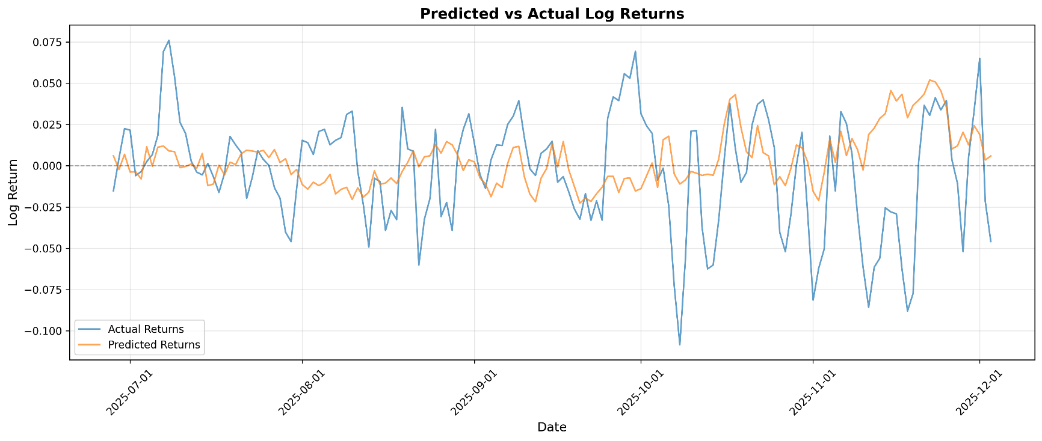
Figure 1. Predictions vs actual log returns.

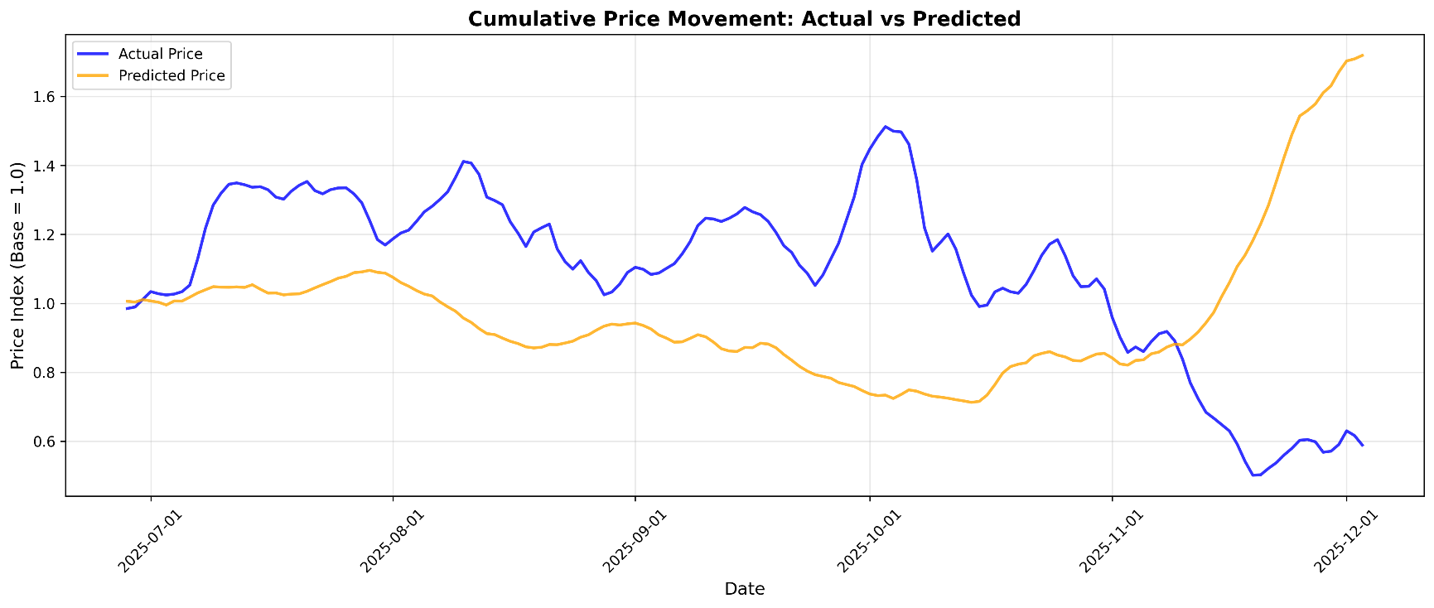
Figure 2. Cumulative return curves (actual vs predicted).

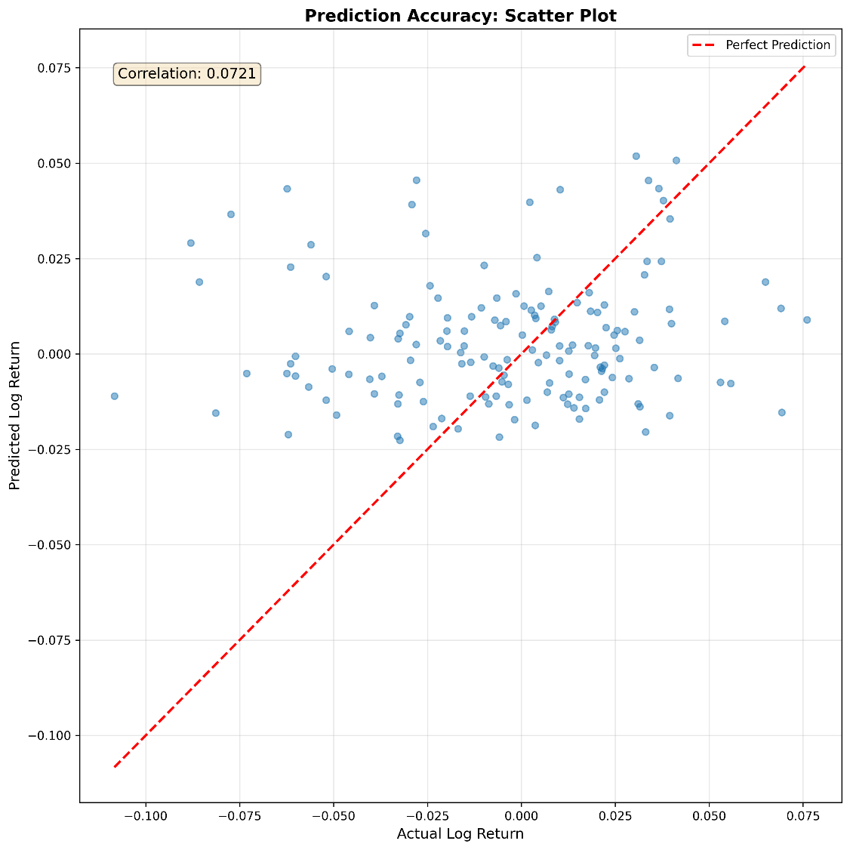
Figure 3. Scatter plot of predictions vs actual (R = 0.072).

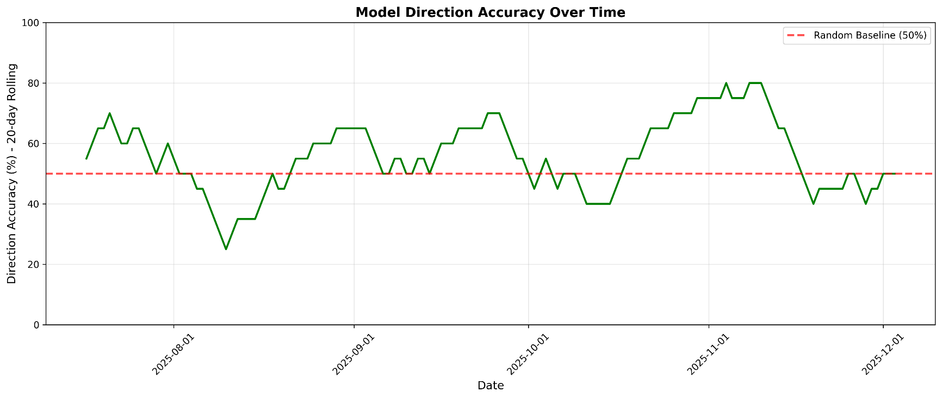
Figure 4. Rolling directional accuracy (20-day window).

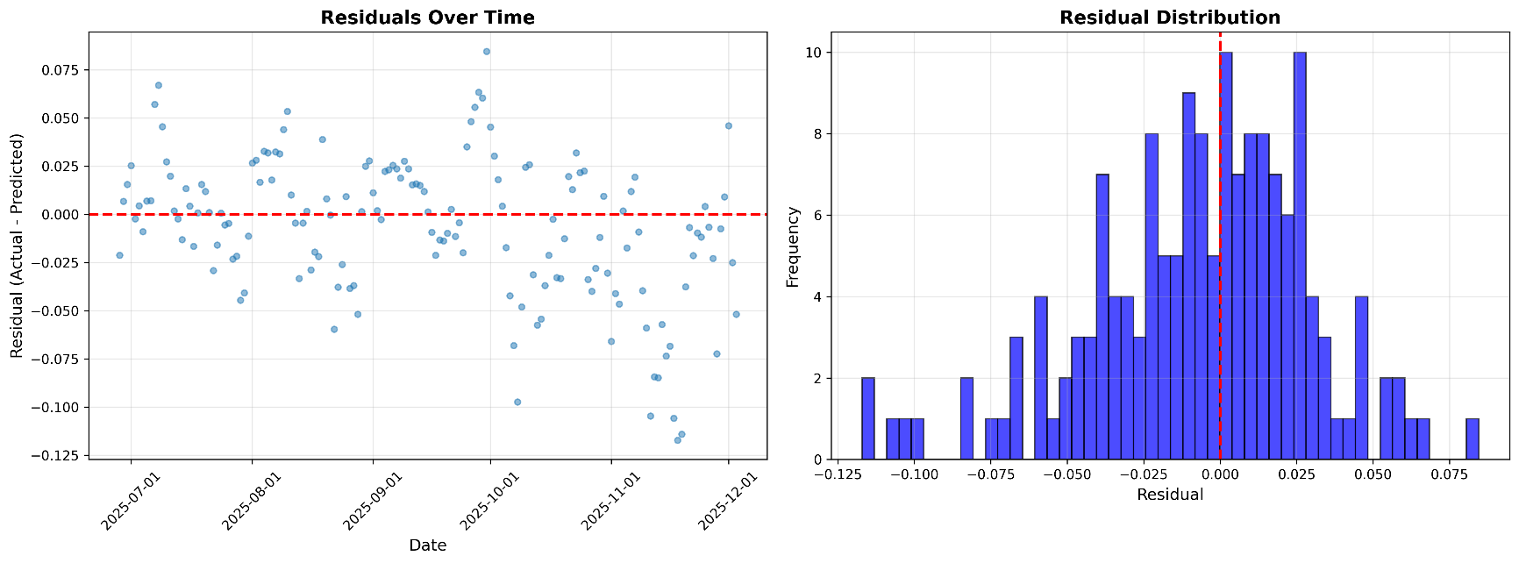
Figure 5. Residual analysis.

- DISCUSSION

Results show that sentiment features provide meaningful predictive signals beyond technical indicators alone. CFGI moving averages and interaction features appear among the top 20 most important predictors. Volatility features dominate importance rankings, consistent with prior literature [6].

The simple long/short strategy yields a high Sharpe ratio and stable performance. Thresholding reduces trading frequency but also reduces returns. The findings demonstrate that simple, stable trading rules often outperform more complex decision policies when forecasting signal strength is modest.

- CONCLUSION

This research demonstrates that automated machine learning ensembles combined with sentiment analysis can produce profitable cryptocurrency forecasting models. A 55.97% directional accuracy and +55% backtested returns indicate that price and sentiment contain useful predictive information. Future work may include walk-forward validation, transformer models, multi-asset extension, and higher-frequency data.

REFERENCES

[1] R. Lahmiri and S. Bekiros, “Crypto-currency forecasting using deep learning,” Journal of Forecasting, vol. 38, no. 1, pp. 22–33, 2019.

[2] T. Fischer and C. Krauss, “Deep learning with long short-term memory networks for financial market predictions,” European Journal of Operational Research, vol. 270, no. 2, pp. 654–669, 2018.

[3] S. Aras and P. Kulkarni, “Sentiment-enhanced cryptocurrency price prediction models,” Expert Systems with Applications, vol. 142, 2020.

[4] R. Tsay, Analysis of Financial Time Series, Wiley, 2010.

[5] J. Bergmeir and J. M. Benítez, “On the use of cross-validation for time series predictor evaluation,” Computational Statistics & Data Analysis, vol. 60, pp. 69–82, 2012.

